Name | ID | STUDENT SIGN
Instructions:
- Make sure to write your Name, ID and Signature on this document.
- First write your signature on a paper then take photo of that signature and use it for signing this document.
- After completing the requirements of the midterm assignment by editing this document, upload this document in the link provided in your VUES Student Account.

Midterm Assignment
- Below a scenario has been given draw the ER Diagram.
Draw with proper annotations (use DIA, VISIO, MS WORD etc.). For reference see ERDiagramTutorial.
In a doctor appointment management system, a patient takes appointment from a doctor and a doctor attend appointment of many patients. A doctor is identified by doctor id, name, address, room no, qualification, specialty, visit, and contact no. There may be multiple contact no of a doctor. A Patient is identified by their unique ID and the system stores their name, mobile number, age and address. A patient address is composed of city name, street number, and house number. One doctor can be associated with many chambers, but one chamber is associated with only one doctor and the system stores the id and address of each chamber, including the city name, street number, and house number. Additionally, one doctor has many compounders, but a compounder is associated with only one doctor and a compounder is identified by their ID, name, and contact numbers. A chamber is maintained by only one compounder and a compounder maintain only one chamber. While taking appointment, the date and time of appointment for each patient is also stored. Furthermore, one doctor can have many schedules, but each schedule is associated with only one doctor and the system stores the id, time and date for each schedule and a compounder can manage many schedules for doctor, but a schedule is managed by one compounder.

Answer 1:

- Below an ER Diagram has been given write the scenario.
For reference see ERDiagramTutorial.
- Below an ER Diagram has been given write the scenario.
For reference see ERDiagramTutorial.

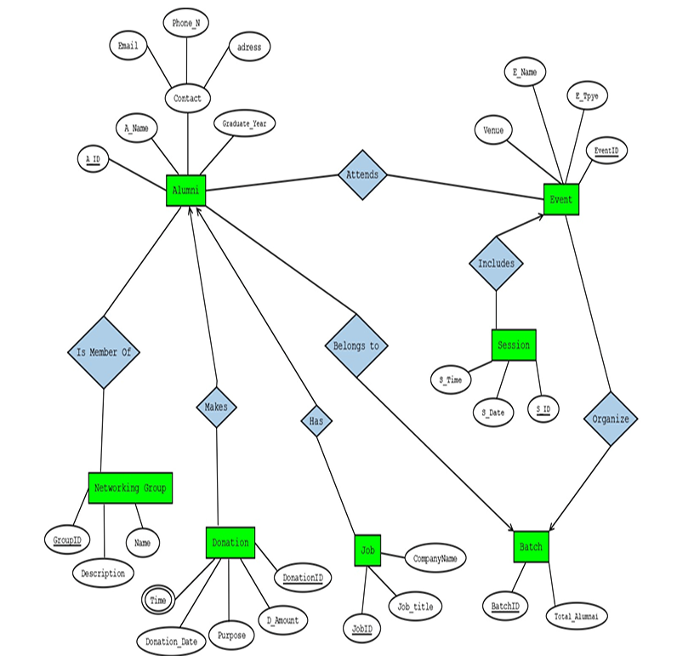

Answer 2:

- Normalize the ER Diagram given below up to 3rd Normal Form and finalize the tables that needs to be created. Then (in Oracle using SQL) write down the queries that are required to create all the tables with necessary constraints. Also insert at least 3 rows of data in each created table.
For reference see NormalizationTutorial and BasicSQLTutorial.

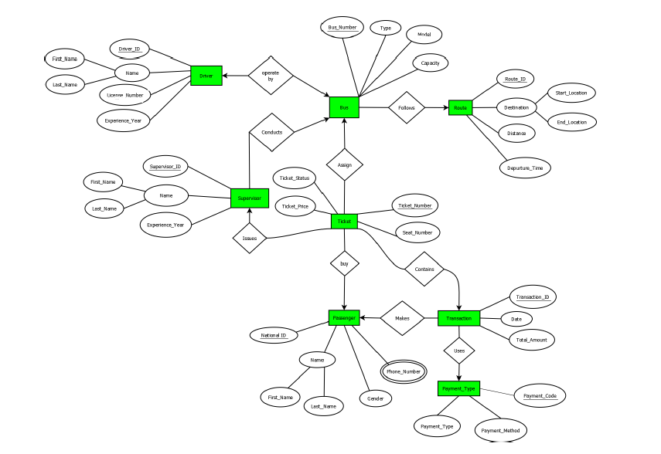

Answer Box (Normalization steps in detail as shown in Normalization Tutorial Slide + all the queries required to create the tables and insert data after Normalization):

- Query Writing (Write down the question and the answer. Give full screenshot of the Oracle 10g Homepage that contains the answer and result)
-All screenshots MUST include the DATE and TIME feature from the screen of the machine (PC, Laptop etc.) used
SQL
-2 single-row function
-2 group function
-2 subquery
-2 joining
For reference see BasicSQLTutorial and AdvanceSQLTutorial.
Answer 4:

